Kendall Miller

10/06/21

SEED LAB 2

**Task 1:**

When a32.out and a64.out were called, the shell code was invoked. Here, an extra line was added to the terminal that began with a $ sign. This shows that it is a user shell, but not a root shell. Commands can be put into this, however I used exit in order to run the next files.

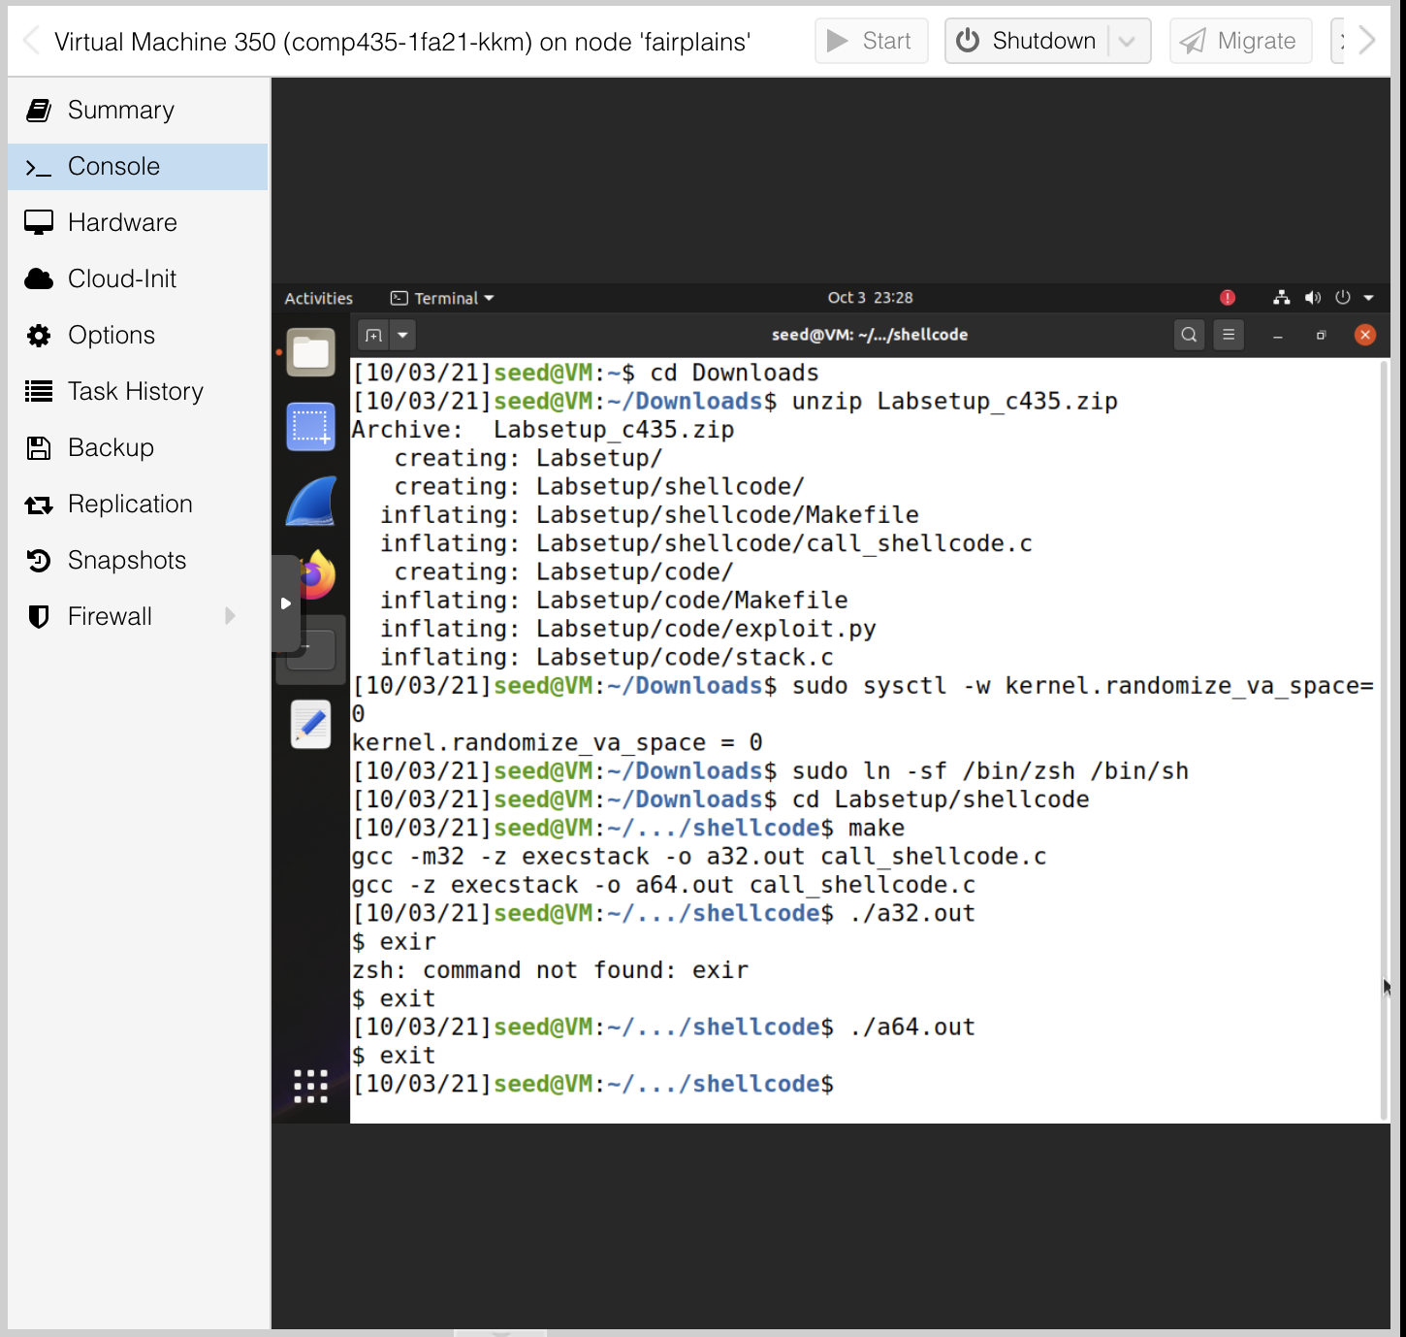

**Task 3:**

To choose the value for offset, I took the difference of the EBP and the buffer address, which was found to be 128. I then added 4 bits to account for the return address field, making the distance 132, which will be the offset in this instance. The return value was found by adding the ebp address with 8 more bytes then the offset. This was chosen because the first address that could be jumped to was ebp + 8, but we needed to account for deeper stack that may have been allocated after running gdb. The start value was chosen by putting the shellcode at the end of the payload, which can be done by making start = 517 – len(shellcode), and then inserting the shellcode at this point, so it fills up the end of the payload array.

As seen below, these values were able to successfully capture the root shell.

** Screen shots of GDP command

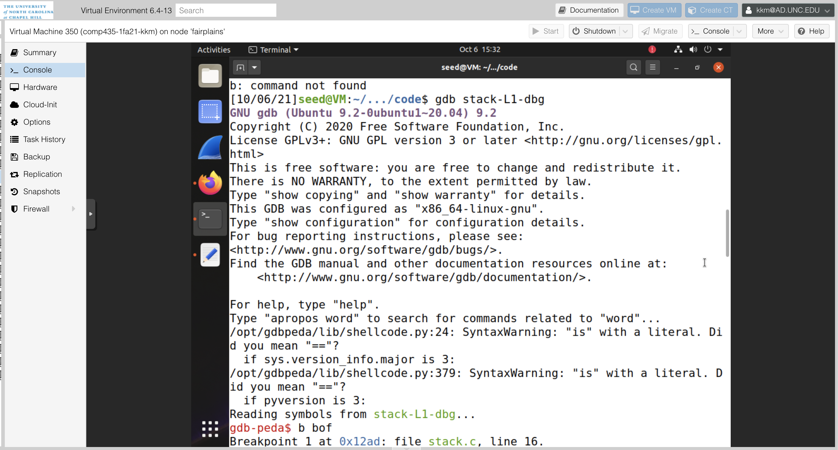

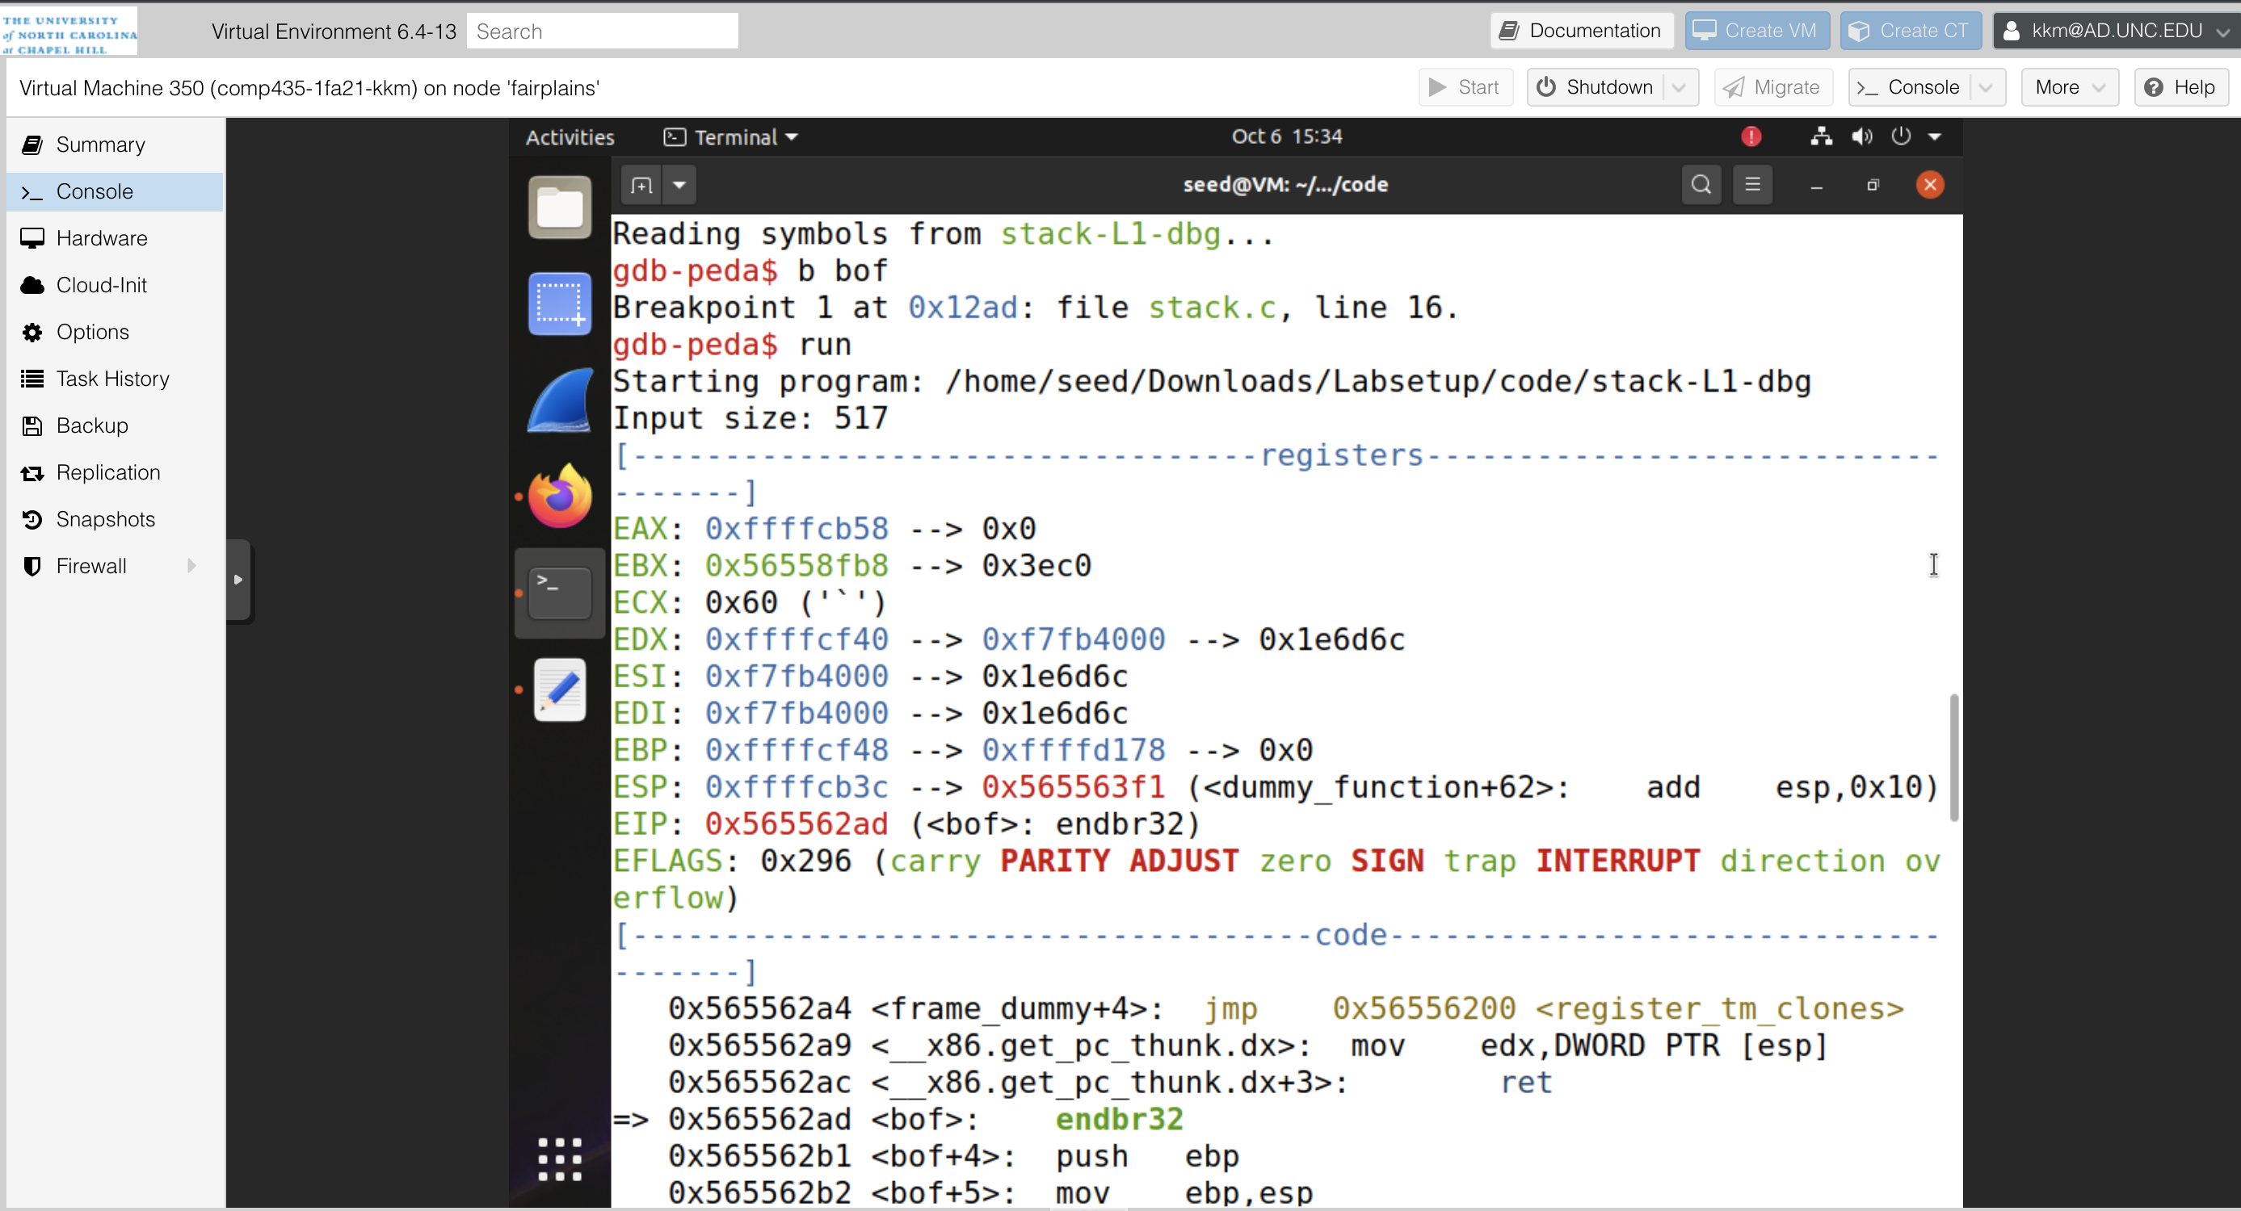

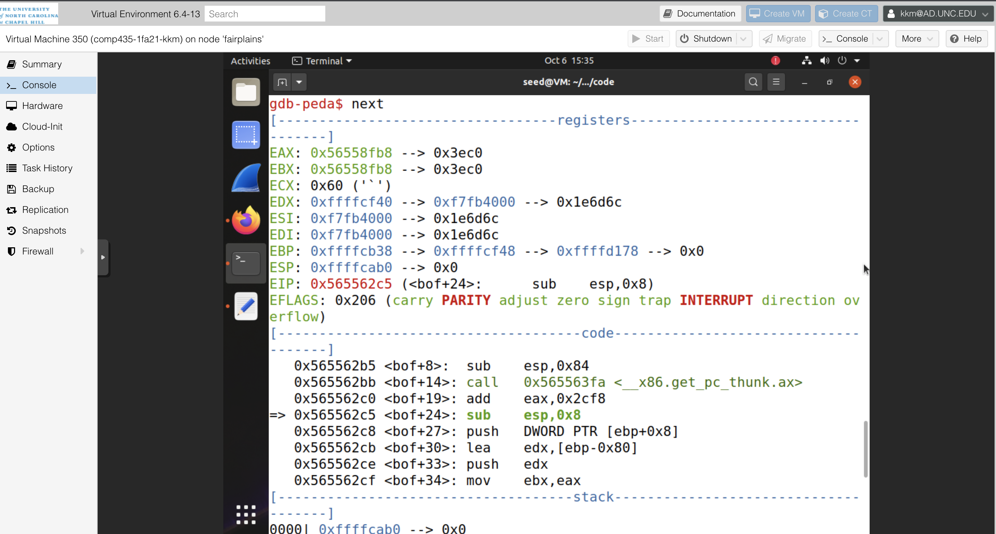

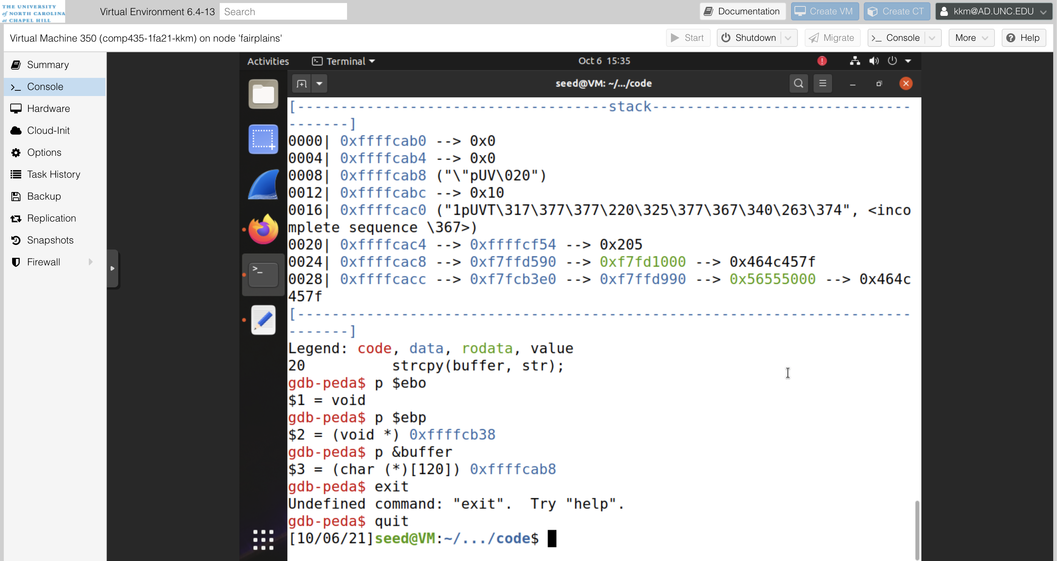

** exploit.py code

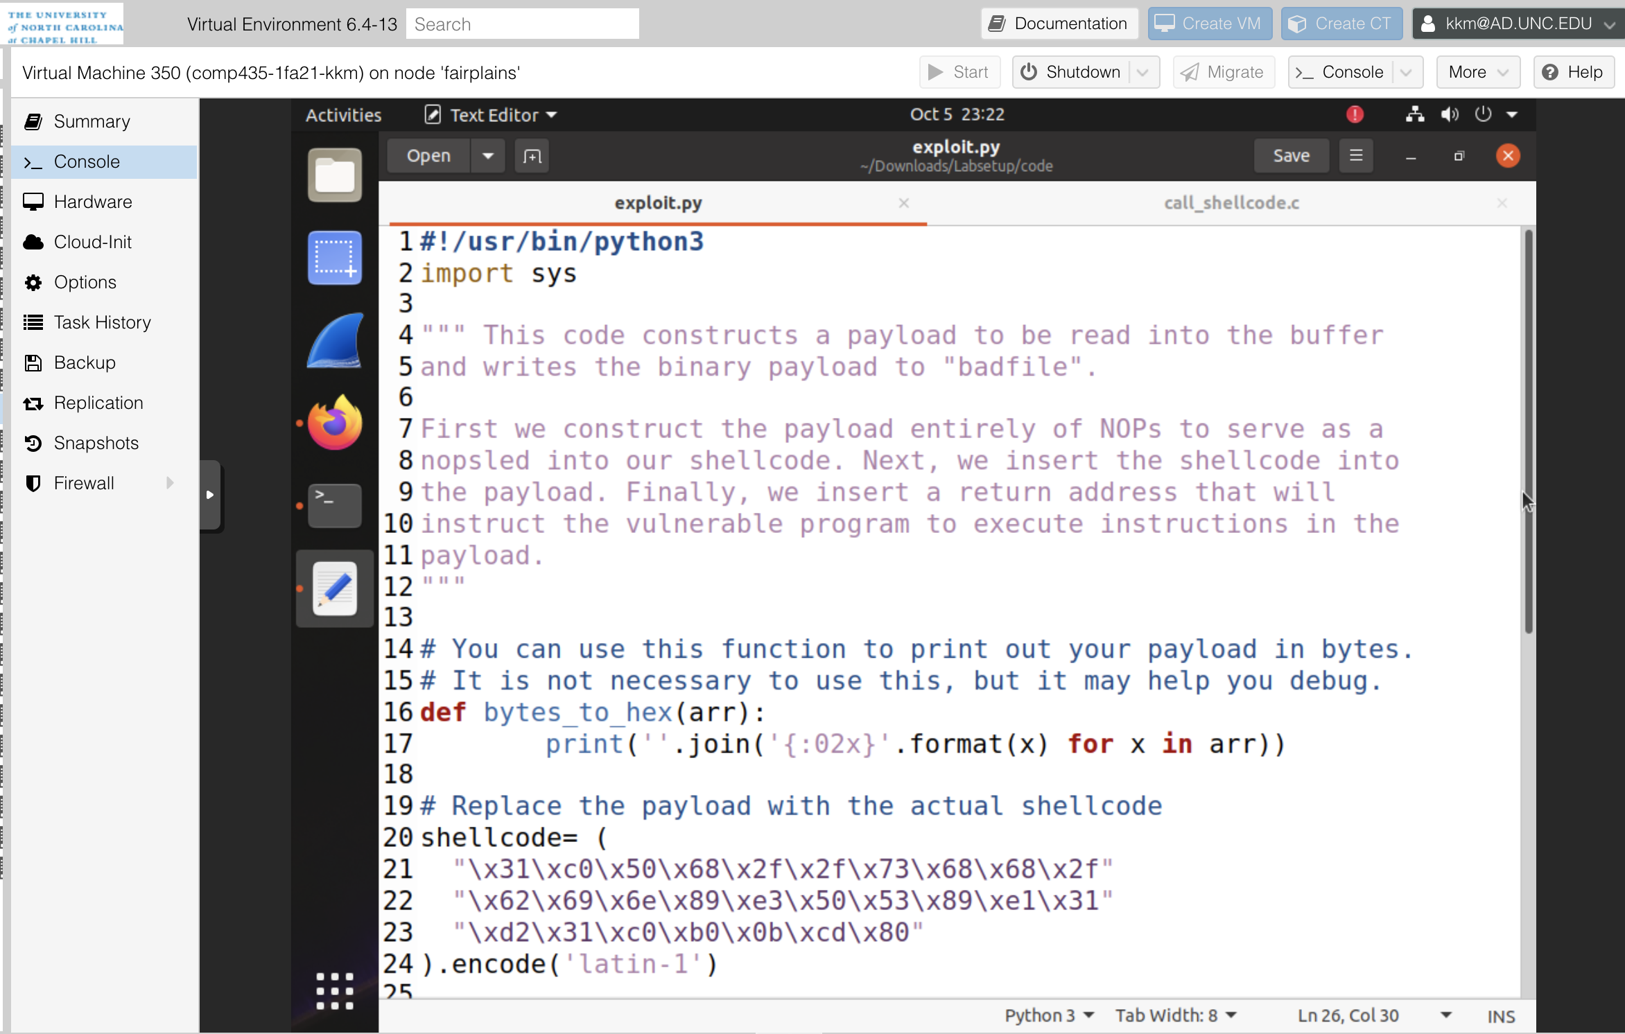  
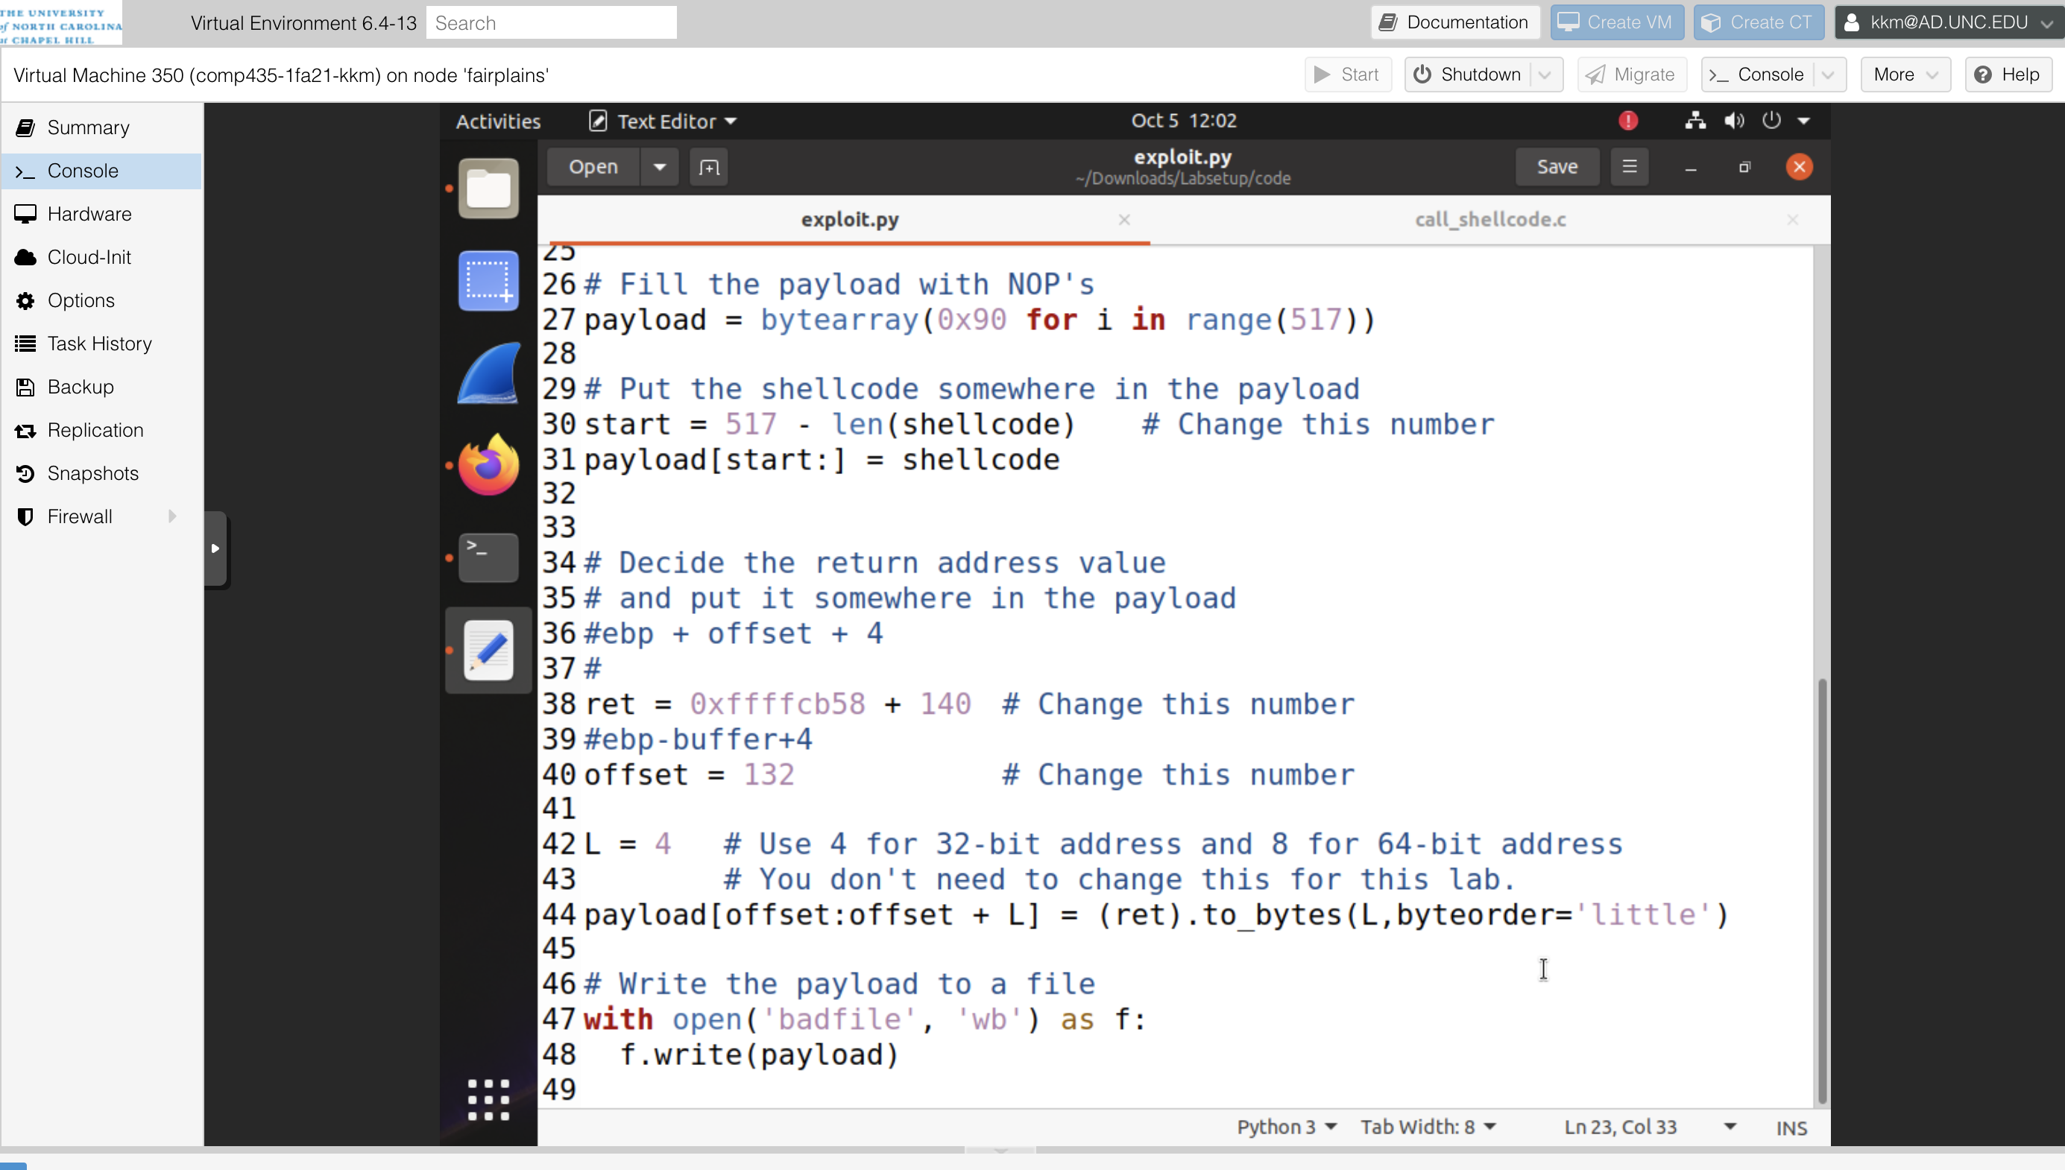

** Successful capture of the root shell

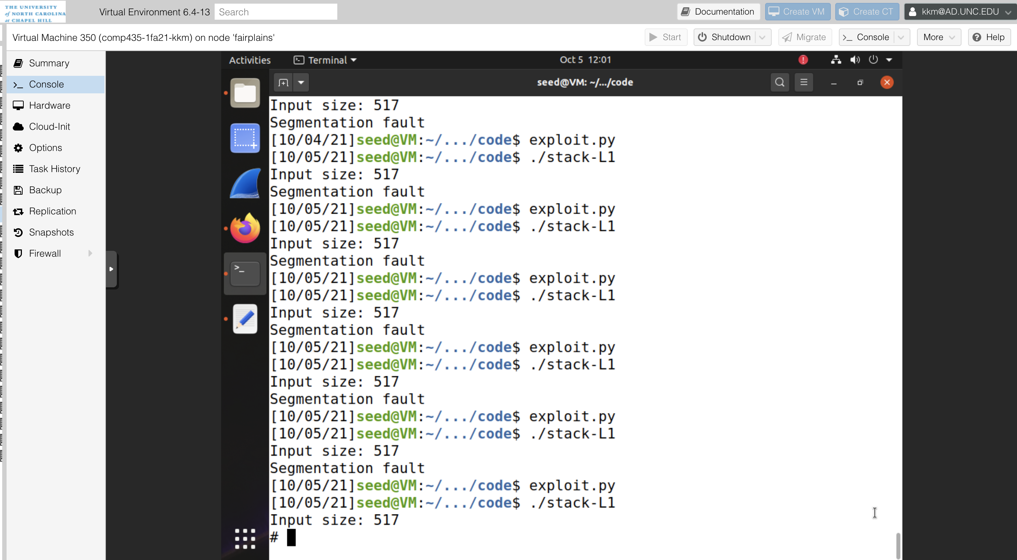

**Task 4:**

For task 4, we were not able to use the buffer address provided to us by the GDP command. In order to do this, I utilized a technique called “spraying,” where we spray the buffer with the return address, so that it is in all possible locations. This allows us to proceed without knowing exactly where the return address should go. We knew that the range of the buffer size was 100-200. This means that the largest possible value from the return address field to the start of the buffer would be 200. I additionally added a 20 size byte buffer to account for any additional space needed, coming out to 220 bytes of the payload to be sprayed. I did this by utilizing a while loop until all 220 bytes were converted to my return value. Because we didn’t know the buffer address, we had to enumerate the possible values that the return value could be using mathematical deduction. We knew that the first 220 byte were the buffer, so I first tried our return value + 220, which ended up being within the range between the buffer and the malicious code, hence why we were able to capture the root shell.

** Successful capture of the root shell

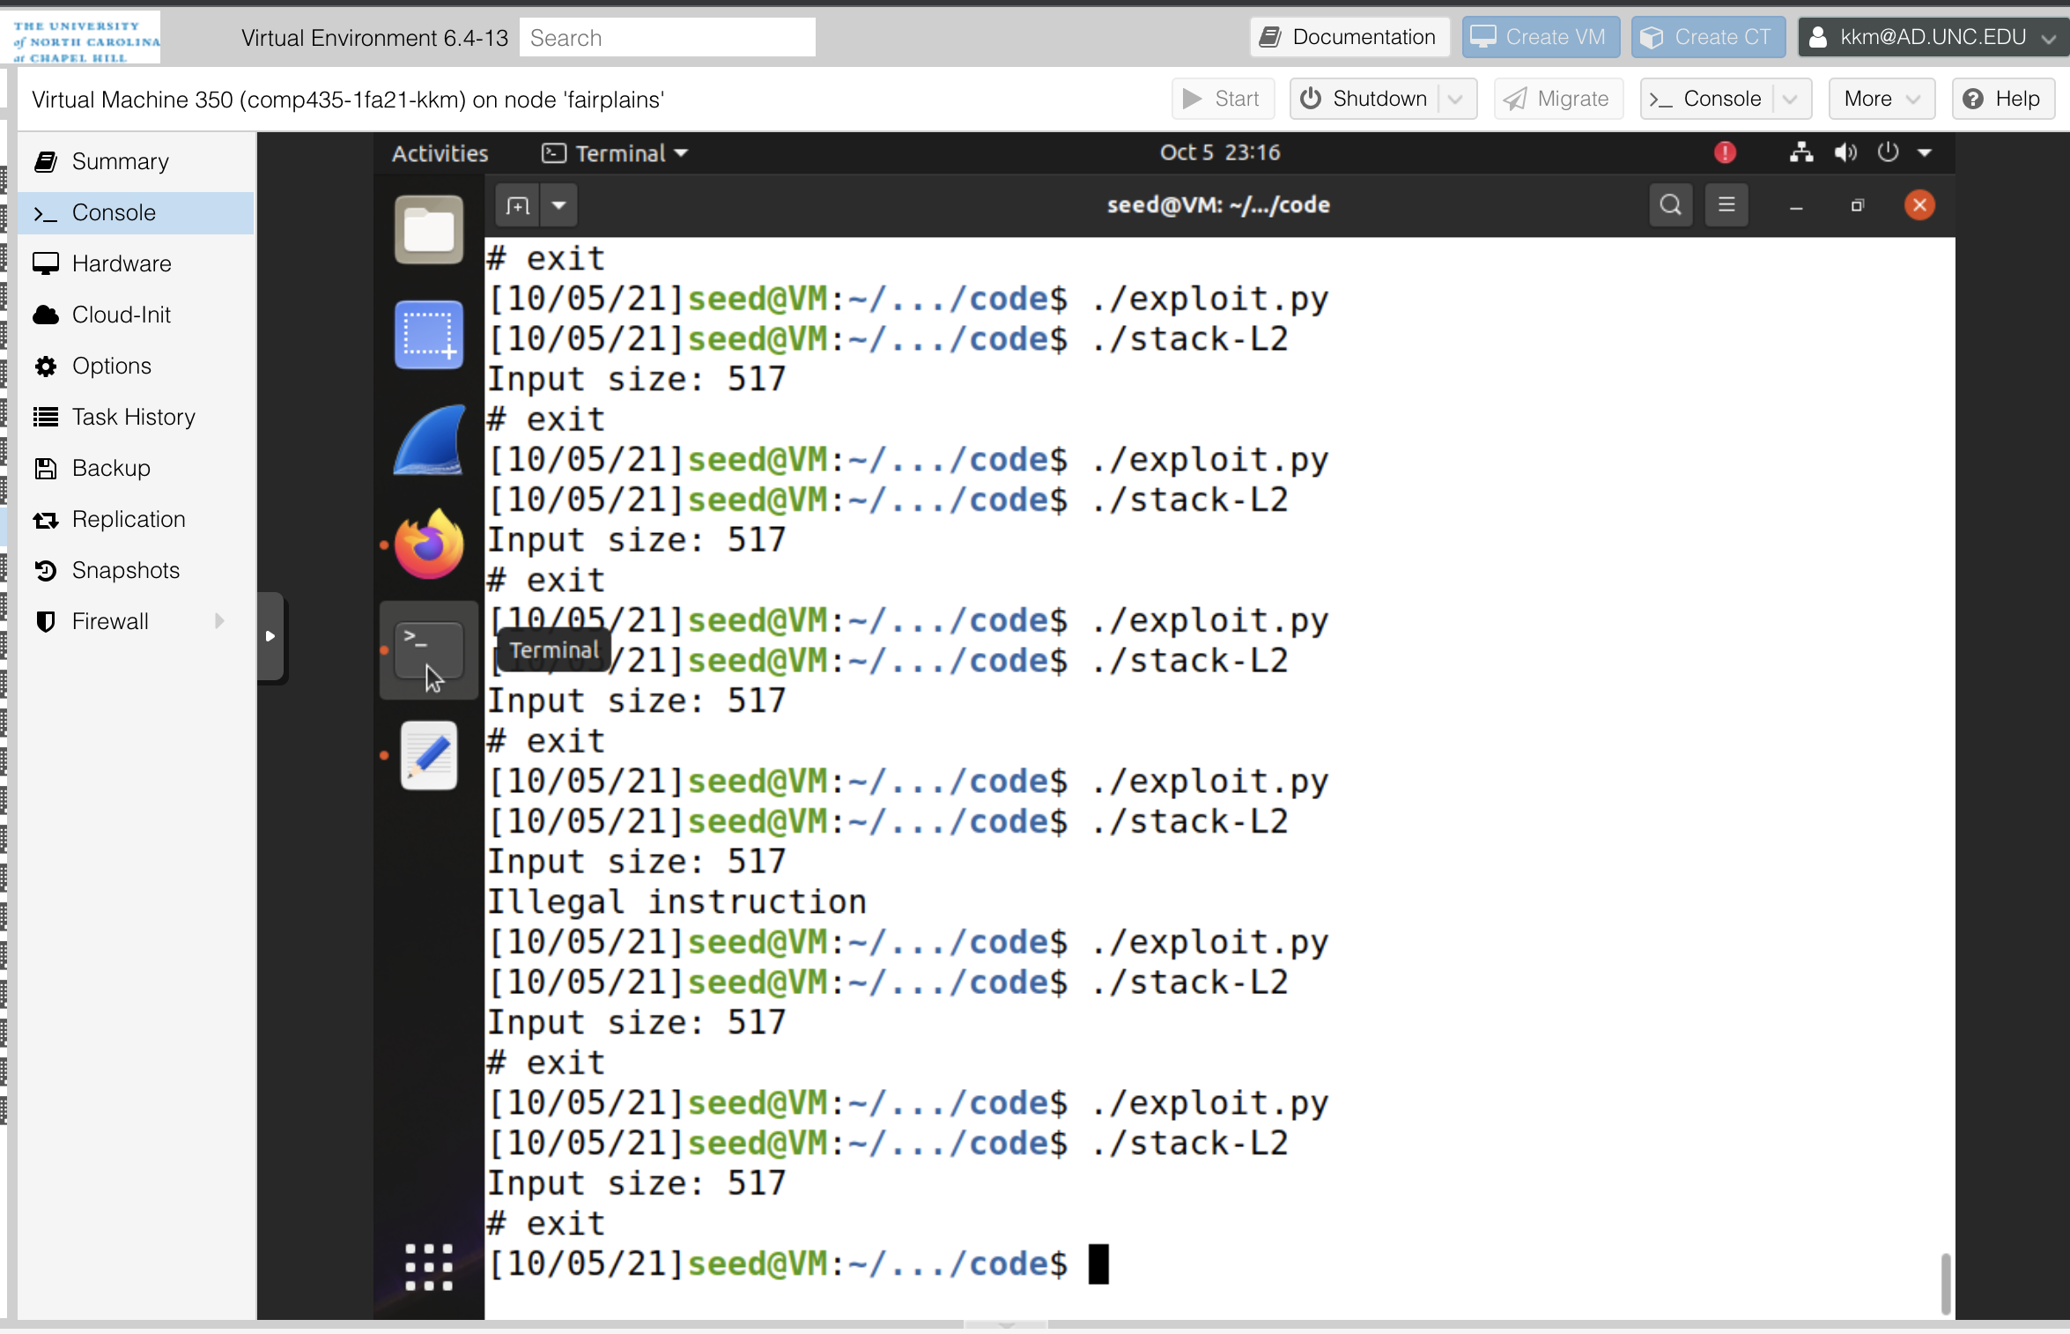

** exploit.py code



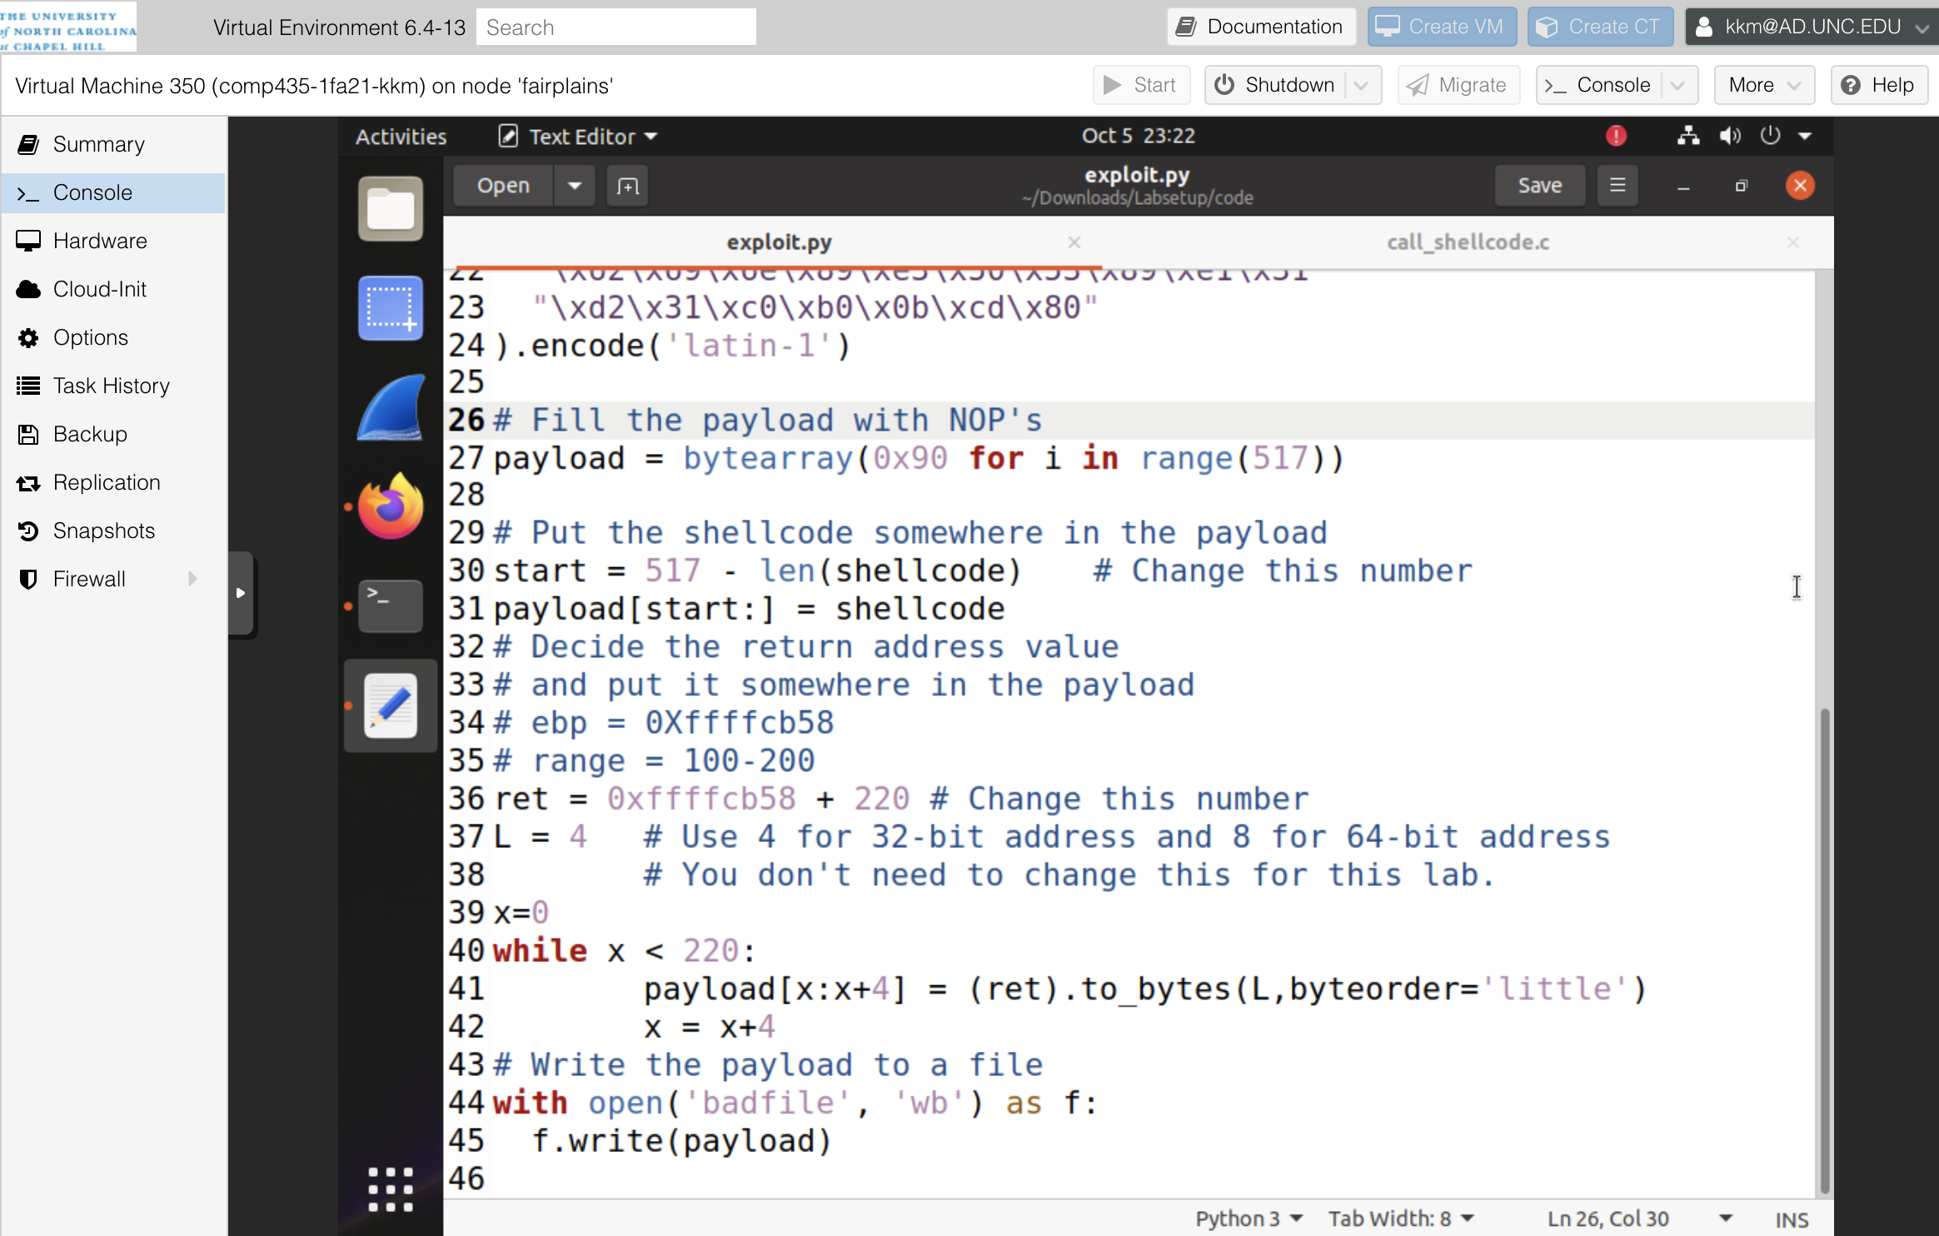

**Task 5:**

The changes I made to the exploit code in task 5 are shown in the picture below. The dash shell in this case stops privileges when it finds that the effective UID doesn’t equal the real UID. When a root-owned SET-UID system runs the effective UID is set to zero, so my task was to change the real UID also to 0. To do this, I converted the additional assembly code to hex, and then added it to the beginning of the payload. This sets the real user ID of the victim process to 0 before invoking dash. Specifically, the first and third lines of the shellcode copy the real setuid into a variable. The second line of shellcode sets a variable to 0, which will be used to pass in the argument 0 into the setuid call. The fourth line of the shellcode actually invokes the system call. Because 0 has been set as real user id, thus equaling the effective-UID, we were able to capture the root shell even though we couldn’t use zsh anymore.

** changes to exploit.py

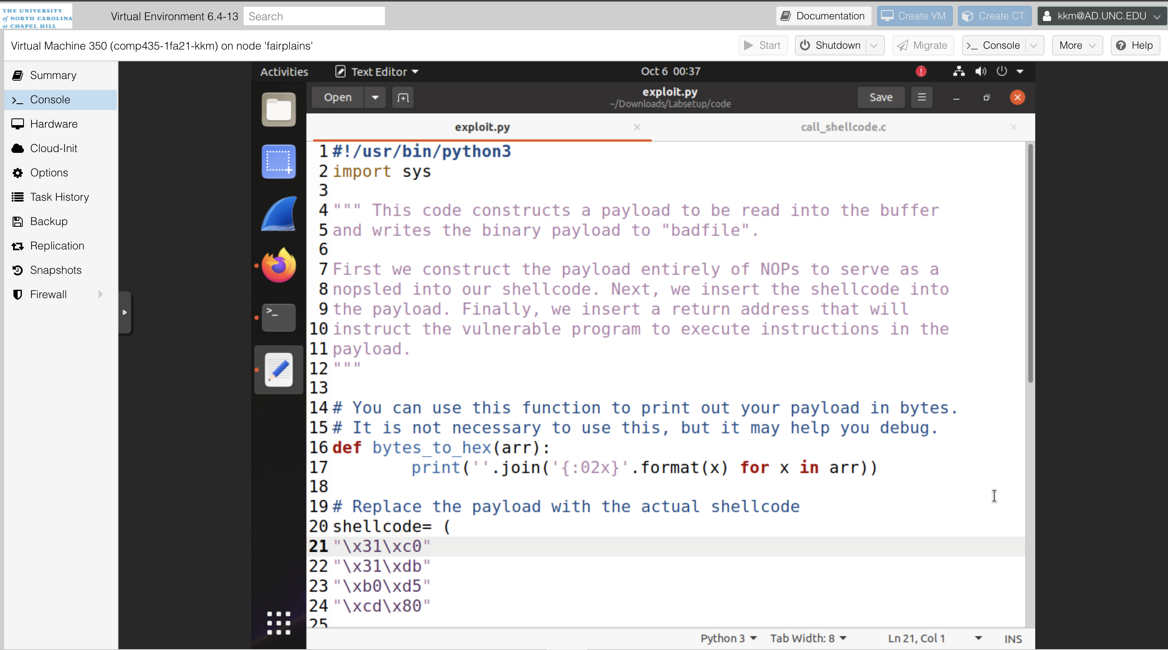

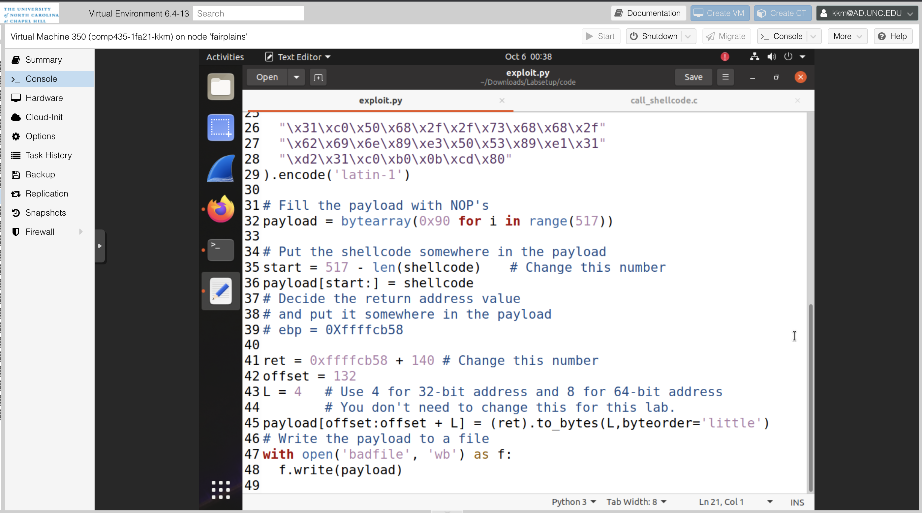

** successfully captured the root shell and ran ls -1 /bin/sh /bin/zsh /bin/dash to prove countermeasure

